MS SQL SERVER
Standard Operating Procedures
(SOP)

Troubleshooting and performance enhancement using DBCC

Submitted to



By



CIS, Wipro Limited

Document Details

Project Name | Innogy SE
Account | CIS
IT Component/Application Title | Troubleshooting and performance enhancement using DBCC
Current Version | 1.5
List of Contributors | Pradipkumar Kansara, Kiran Bhalekar, Ayushi Gautam, Sivakumar Goud, Ayushi Srivastava
Customer Contact Information

Version History
(All revisions made to this document must be listed in chronological order. All revisions must be approved. Review and Approval can be done by an internal source or by the customer)
Version | Date of Revision | Description | Author | Reviewed By | Approved By
1.0 | 29-08-2015 | Intial Draft | Kiran Bhalekar | Pradipkumar Kansara | Mahesh Keshatwar
1.1 | 04-09-2015 | Document Completed | Kiran Bhalekar | Pradipkumar Kansara | Mahesh Keshatwar
1.2 | 21-08-2016 | Updated document to standard format | Ayushi Gautam | Pradipkumar Kansara | Mahesh Keshatwar
1.3 | 14-05-2017 | Wipro and Innogy Logo changed | Sivakumar Goud | Pradipkumar Kansara | Mahesh Keshatwar
1.4 | 16-08-2017 | Updated document to Wipro Standard format with header and footer | Kiran Bhalekar | Pradipkumar Kansara | Santosh Badiger
1.5 | 18-12-2018 | Updated the content | Ayushi Srivastava | Pradipkumar Kansara | Santosh Badiger

Document Distribution List
S.No | Name and Company | Purpose
1 | RWEIT-SQLDBA | This document is useful for troubleshooting and performance enhancement
2

TABLE OF CONTENT
1. Purpose 1
2. Scope 1
3. Performance Enhancement Using Dbcc 1
3.1. Validation Statements 1
3.1.1 Dbcc Checkalloc 1
Syntax: 1
Arguments: 2
Example 2
3.1.2 Dbcc Checkcatalog 3
Syntax: 3
Arguments 3
Example 4
1.1.1 Script 4
3.1.3 Dbcc Checktable 4
Syntax 4
Arguments 5
Example 6
3.1.4 Dbcc Checkfilegroup 7
Syntax 7
Arguments 7
Example 8
3.1.5 Dbcc Checkident 9
Syntax 9
Arguments 9
Example 10
3.2 Maintenance Statement 10
3.2.1 Dbcc Shrinkdatabse 10
Syntax 10
Arguments 10
Example 11
4. Note 12
5. Reference 12

1. Purpose
This document is prepared for the management and troubleshooting of SQL Server Database Administration Services at <Customer Name>.

2. Scope
This document is prepared for GSMC Wipro sustenance team and provides the concepts, management and troubleshooting aspects of troubleshooting and Performance enhancement using dbcc for the administration of the SQL Server database at <Customer Name>.

3. Performance Enhancement Using DBCC
DBCC stands for database consistency checker. We use these commands to check the consistency of the databases, i.e., maintenance and validation task.

3.1. Validation Statements

3.1.1 DBCC Checkalloc
Checks the consistency of disk space allocation structures for a specified database.

Syntax:
DBCC CHECKALLOC
[
(
[ 'database_name' | database_id | 0 ]
[ , NOINDEX
|
{ REPAIR_ALLOW_DATA_LOSS
| REPAIR_FAST
| REPAIR_REBUILD
} ]
)
]
[ WITH { [ ALL_ERRORMSGS ]
[ , NO_INFOMSGS ]
[ , TABLOCK ]
[ , ESTIMATEONLY ]
}
]

Arguments:
'database_name' | database_id | 0:

Is the name or the ID of the database for which to check allocation and page usage. If not specified, or if 0 is specified, the current database is used.
Database names must follow the rules for identifiers.

NOINDEX:

Specifies that nonclustered indexes for user tables should not be checked.

REPAIR_ALLOW_DATA_LOSS | REPAIR_FAST | REPAIR_REBUILD:

Specifies that DBCC CHECKALLOC repair the found errors. database_name must be in single-user mode.

REPAIR_ALLOW_DATA_LOSS:

Tries to repair any errors that are found. These repairs can cause some data loss. REPAIR_ALLOW_DATA_LOSS is the only option that allows for allocation errors to be repaired.

REPAIR_FAST:

Maintained for backward compatibility only.

REPAIR_REBUILD:
Not applicable.

Example
DBCC CHECKALLOC ('CHOLAHRMS')

Output

Table TSUK_ACCREDITATIONS_T Object ID 395148453.
Index ID 1, partition ID 307371425726464, alloc unit ID 307371425726464 (type In-row data). FirstIAM (0:0). Root (0:0). Dpages 0.
Index ID 1, partition ID 307371425726464, alloc unit ID 307371425726464 (type In-row data). 0 pages used in 0 dedicated extents.
Total number of extents is 0.

3.1.2 DBCC Checkcatalog
Checks for catalog consistency within the specified database. The database must be online.

DBCC CHECKCATALOG performs various consistency checks between system metadata tables. DBCC CHECKCATALOG uses an internal database snapshot to provide the transactional consistency that it needs to perform these checks.

If a snapshot cannot be created DBCC CHECKCATALOG acquires an exclusive database lock to obtain the required consistency. If any inconsistencies are detected, they cannot be repaired and the database must be restored from a backup.

Syntax:

DBCC CHECKCATALOG
[
(
'database_name' | database_id | 0
)
]
[ WITH NO_INFOMSGS ]

Arguments

'database_name' | database_id | 0 :

Is the name or ID of the database for which to check catalog consistency. If not specified, or if 0 is specified, the current database is used. Database names must comply with the rules for identifiers.

WITH NO_INFOMSGS :

Suppresses all informational messages.

Example
    - Script

DBCC CHECKCATALOG ('CHOLAHRMS');
GO

OUTPUT

DBCC execution completed. If DBCC printed error messages, contact your system administrator.

3.1.3 DBCC Checktable
Checks the integrity of all the pages and structures that make up the table or indexed view.

Syntax
DBCC CHECKTABLE
(
'table_name' | 'view_name'
[ , NOINDEX
| index_id
| { REPAIR_ALLOW_DATA_LOSS
| REPAIR_FAST
| REPAIR_REBUILD }
]
)
[ WITH
{ [ ALL_ERRORMSGS ]
[ , [ NO_INFOMSGS ] ]
[ , [ TABLOCK ] ]
[ , [ ESTIMATEONLY ] ]
[ , [ PHYSICAL_ONLY ] ]
}
]

Arguments

'table_name' | 'view_name'

Is the table or indexed view for which to run integrity checks. Table or view names must comply with the rules for identifiers.

NOINDEX

Specifies that intensive checks of nonclustered indexes for user tables should not be performed. This decreases the overall execution time. NOINDEX does not affect system tables because the integrity checks are always performed on all system table indexes.

index_id

Is the index identification (ID) number for which to run integrity checks. If index_id is specified, DBCC CHECKTABLE runs integrity checks only on that index, together with the heap or clustered index.

REPAIR_ALLOW_DATA_LOSS | REPAIR_FAST | REPAIR_REBUILD

Specifies that DBCC CHECKTABLE repair the found errors. To use a repair option, the database must be in single-user mode.

REPAIR_ALLOW_DATA_LOSS

Tries to repair all reported errors. These repairs can cause some data loss.

REPAIR_FAST

Maintained for backward compatibility only.

REPAIR_REBUILD

Performs all repairs made by REPAIR_FAST and includes repairs such as rebuilding indexes. These repairs might take some time but can be performed without risk of data loss.

WITH

Enables options to be specified.

ALL_ERRORMSGS

Displays an unlimited number of errors. If ALL_ERRORMSGS is not specified, only the first 200 error messages are displayed.

NO_INFOMSGS

Suppresses all informational messages.

TABLOCK

Causes DBCC CHECKTABLE to obtain a shared table lock instead of using an internal database snapshot. TABLOCK will cause DBCC CHECKTABLE to run faster on a table under heavy load, but decreases the concurrency available on the table while DBCC CHECKTABLE is running.

ESTIMATEONLY

Displays the estimated amount of tempdb space needed to run DBCC CHECKTABLE with all the other specified options.

PHYSICAL_ONLY

Limits the checking to the integrity of the physical structure of the page, record headers and the physical structure of Btrees. Designed to provide a small overhead check of the physical consistency of the table, this check can also detect torn pages, and common hardware failures that can compromise data.

Example
DBCC CHECKTABLE
(
'UsrParam')

Output

DBCC results for 'UsrParam'.
There are 253 rows in 16 pages for object "UsrParam".
DBCC execution completed. If DBCC printed error messages, contact your system administrator.

3.1.4 DBCC Checkfilegroup
Checks the allocation and structural integrity of all tables, in the current database, in the specified filegroup.

Script

Syntax
DBCC CHECKFILEGROUP
[
(
[ { 'filegroup_name' | filegroup_id | 0 } ]
[ , NOINDEX ]
)
]
[ WITH
{
[ ALL_ERRORMSGS ]
[ NO_INFOMSGS ] ]
[ , [ TABLOCK ] ]
[ , [ ESTIMATEONLY ] ]
}
]

Arguments
'filegroup_name'

Is the name of the filegroup for which to check table allocation and structural integrity. If not specified, or if 0 is specified, the default is the primary filegroup. References to filegroup are only relevant in the current database. Filegroup names must comply with the rules for identifiers.

filegroup_id

Is the filegroup identification (ID) number for which to check table allocation and structural integrity. References to filegroup are only relevant in the current database. .

NOINDEX

Specifies that intensive checks of nonclustered indexes for user tables should not be performed. This decreases the overall execution time. NOINDEX does not affect system tables because
DBCC CHECKDB always checks all system table indexes.

WITH

Specifies options on the number of error messages returned, locks obtained, or estimating tempdb requirements. If neither ALL_ERRORMSGS nor NO_INFOMSGS is specified, all error messages are returned.

ALL_ERRORMSGS

Displays an unlimited number of errors per object. If ALL_ERRORMSGS is not specified, only the first 200 error messages for each object are displayed. .

NO_INFOMSGS

Suppresses all informational messages.

TABLOCK

Causes DBCC CHECKFILEGROUP to obtain locks instead of using an internal database
snapshot.

ESTIMATE ONLY

Displays the estimated amount of tempdb space required to run DBCC CHECKFILEGROUP with all the other specified options.

Example

DBCC CHECKFILEGROUP (1)

Output

There are 380 rows in 9 pages for object "DpLogMst".
DBCC results for 'SecLmt'.
There are 799 rows in 33 pages for object "SecLmt".
CHECKFILEGROUP found 0 allocation errors and 0 consistency errors in database 'NLADS_CH'.
DBCC execution completed. If DBCC printed error messages, contact your system administrator.

3.1.5 DBCC Checkident
Checks the current identity value for the specified table and, if it is needed, changes the identity value.

Syntax
DBCC CHECKIDENT
(
'table_name'
[ , {
NORESEED | { RESEED [ , new_reseed_value ] }
}
]
)
[ WITH NO_INFOMSGS ]

Arguments
'table_name'

Is the name of the table for which to check the current identity value. The table specified must contain an identity column. Table names must comply with the rules for identifiers.

NORESEED

Specifies that the current identity value should not be changed.

RESEED

Specifies that the current identity value should be changed.

new_reseed_value

Is the new seed value to use in reseeding the identity column.

WITH NO_INFOMSGS
Suppresses all informational messages.

Example
Script

DBCC CHECKIDENT
(
'DpLogMst')

Output

Checking identity information: current identity value '380', current column value '380'.
DBCC execution completed. If DBCC printed error messages, contact your system administrator.

3.2 Maintenance Statement

3.2.1 DBCC Shrinkdatabse
Shrinks the size of the data files in the specified database.

Syntax
DBCC SHRINKDATABASE
( 'database_name' | database_id | 0
[ ,target_percent ]
[ , { NOTRUNCATE | TRUNCATEONLY } ]
)
[ WITH NO_INFOMSGS ]

Arguments

'database_name' | database_id | 0

Is the name or ID of the database to be shrunk. If 0 is specified, the current database is used. Database names must comply with the rules for identifiers.

target_percent

Is the percentage of free space that you want left in the database file after the database has been shrunk.

NOTRUNCATE

Causes the freed file space to be retained in the database files. If not specified, the freed file space is released to the operating system.

TRUNCATEONLY

Causes any unused space in the data files to be released to the operating system and shrinks the file to the last allocated extent, reducing the file size without moving any data. No attempt is made to relocate rows to unallocated pages. target_percent is ignored when TRUNCATEONLY is used.

WITH NO_INFOMSGS

Suppresses all informational messages that have severity levels from 0 through 10.

Example

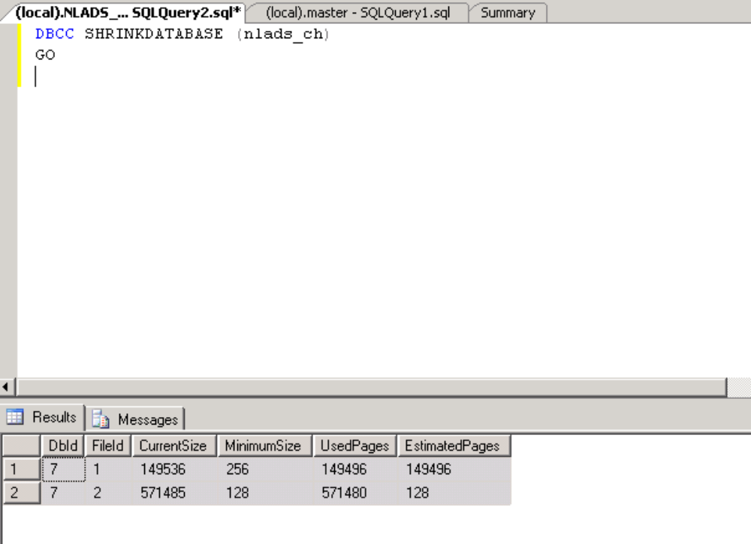

4. Note
1. If DBCC CHECKALLOC reports any errors, we recommend restoring the database from the database backup instead of running a repair. If a backup does not exist, running a repair can correct the reported errors; however, correcting the errors might require some pages, and therefore data, to be deleted.
A repair can be performed in a user transaction. This allows for changes to be rolled back. If changes are rolled back, the database will still contain errors and must be restored from a backup. After the repairs finish, back up the database.

2. The same is applicable for DBCC CHECKTABLE.

5. Reference
- http://msdn.microsoft.com/en-us/library/aa258281(v=SQL.80).aspx

